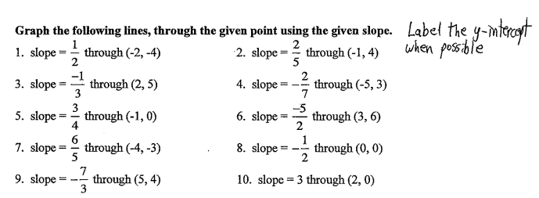

WS #14 4/15/2015 Name: ___________________

