Finding Area or Regular Polygons Name: _____________________
(other than ∆’s, Squares and Hexagons)
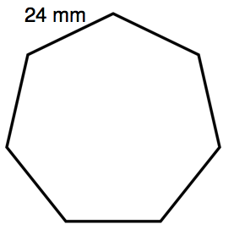
Find the area given a side length.

- How many sides does the polygon have?
- Determine an interior angle measure.
- Sketch in two consecutive radii from the center C to form a central ∆.
- Determine all angle measures of this triangle.
- Draw the apothem inside this triangle.
- What right triangles do you have?
- Use trigonometry ratios to determine the length of the apothem.
- Calculate the area.

Find the area given a radius
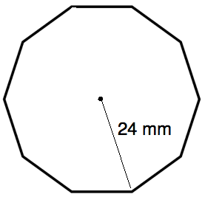
- How many sides does the polygon have?
- Determine an interior angle measure.
- Sketch in two consecutive radii from the center C to form a central ∆.
- Determine all angle measures of this triangle.
- Draw the apothem inside this triangle.
- What right triangles do you have?
- Use trigonometry ratios to determine the length of the apothem.
- Calculate the area.

Finding Area or Regular Polygons Name: _____________________
(other than ∆’s, Squares and Hexagons)
Find the area given a side length.

- How many sides does the polygon have?
- Determine an interior angle measure.
- Sketch in two consecutive radii from the center C to form a central ∆.
- Determine all angle measures of this triangle.
- Draw the apothem inside this triangle.
- What right triangles do you have?
- Use trigonometry ratios to determine the length of the apothem.
- Calculate the area.

Find the area given a radius
- How many sides does the polygon have?
- Determine an interior angle measure.
- Sketch in two consecutive radii from the center C to form a central ∆.
- Determine all angle measures of this triangle.
- Draw the apothem inside this triangle.
- What right triangles do you have?
- Use trigonometry ratios to determine the length of the apothem.
- Calculate the area.

