Exploration: Find the areas (or expressions) of the triangles.

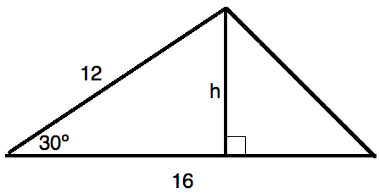

A = _______

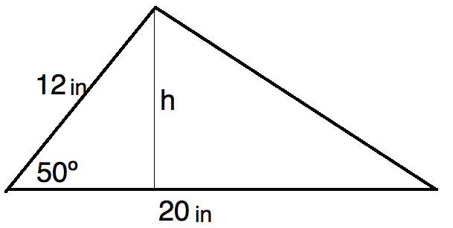

A = _______

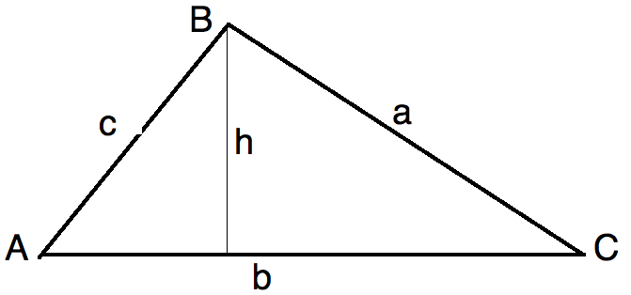

A = _____________