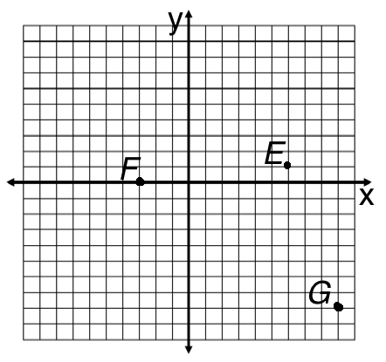
Step 1

Plot the points. State which quadrant the point is in.
1. Plot: A(4, -3), Q: ____ 2. Plot: B(-3, -7), Q: ____

3. Plot: C(-4, 3), Q: ____ 4. Plot: D(0, -3),
which axis is D on? ____axis
Give the coordinates for the following points.
5. E( , ) 6. F( , ) 7. G( , )

Step 2
Fill in the missing parts of the table(s) and then sketch the graphs.
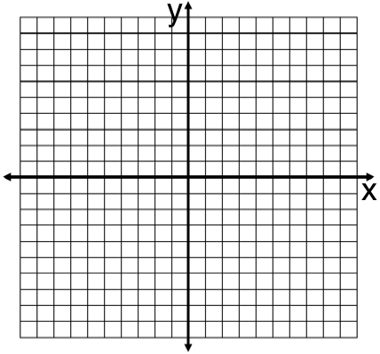
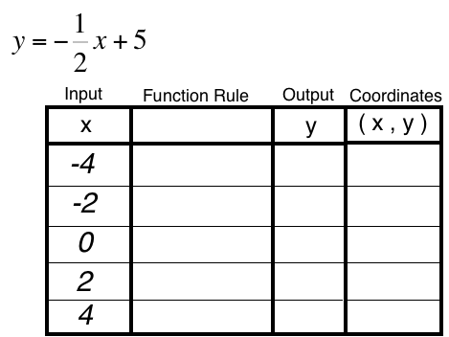
1. 2.
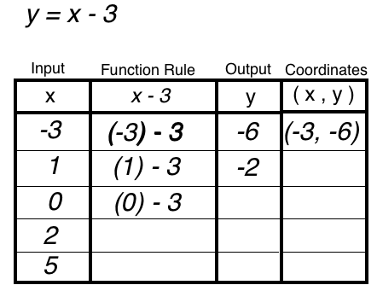

Step 3
Names: __________________________
_________________________________
________________________________
Fill in the tables by choosing your own x values.
Then sketch the graphs.
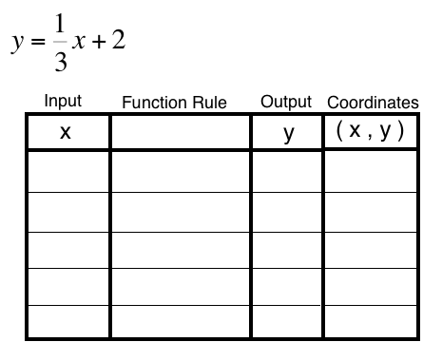
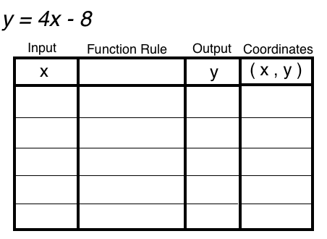
1. 2.
Hint: When you have a fraction, then choose numbers that are easy to multiply by the fraction and will cancel the denominator.

Step 1

Plot the points. State which quadrant the point is in.
1. Plot: A(4, -3), Q: ____ 2. Plot: B(-3, -7), Q: ____

3. Plot: C(-4, 3), Q: ____ 4. Plot: D(0, -3),
which axis is D on? ____axis
Give the coordinates for the following points.
5. E( , ) 6. F( , ) 7. G( , )

Step 2
Fill in the missing parts of the table(s) and then sketch the graphs.
1. 2.

Step 3
Names: __________________________
_________________________________
________________________________
Fill in the tables by choosing your own x values.
Then sketch the graphs.
1. 2.
Hint: When you have a fraction, then choose numbers that are easy to multiply by the fraction and will cancel the denominator.

