Ch 7 Practice Test Name:_______________

Find the value of each expression. (1 pt. each)
2⁰ = ___ 5⁻² = ___ -9² = ___ $3^{4}=____$ (-9)² = ___ ${-\left(\frac{3}{4}\right)}^{2}= ___$

Evaluate each expression for x = 3 and y = -2. Show work underneath each problem. (2 pts each)
$\frac{2x}{y^{3}}= ________$ $\left(3x^{3}y\right)\left(4y\right)= ________$ $\left(2x^{-2}y\right)\left(5y^{-1}\right)=________$

Write an equivalent expression. Answer should contain only positive exponents. (2 pts)
$\left(-5ab\right)\left(2a^{-3}b^{5}\right)\left(4a^{4}\right)=____________$ $\frac{12yz}{-24y^{5}z}=____________$ $\left(7a^{6}b\right)\left(-5a^{3}b\right)=____________$

${(2c^{5})}^{3}=____________$ $\left(\frac{25m^{-3}n}{5m^{3}n^{-4}}\right)=____________$ $a^{7}a^{-2}a^{-11}=_________{ \left(\frac{x^{5}}{y^{-2}}\right)}^{-4}=____________$

Enter an expression equivalent to $a^{24}$ in the form, ${\left(a^{n}\right)}^{m}$. (1 pt)

Enter an expression equivalent to $a^{5}$ in the form $a^{-m}a^{n}$. (1 pt)

Select all expressions equivalent to ${\left(3^{7}∙3^{-3}\right)}^{-1}.$ (2 pts)
- $-81$
- $\frac{1}{81}$
- $3^{-10}∙3^{6}$
- $3^{3}∙3^{-7}$

Determine whether each function represents exponential growth or decay. Select the correct option for each function and explain your answer. (1 pt. each)
Function | Growth | Decay | Explain
$f\left(x\right)={\left(\frac{1}{4}\right)}^{x}$
$f\left(x\right)={\left(\frac{5}{6}\right)}^{4x}$
$f\left(x\right)={\left(\frac{7}{5}\right)}^{4x}$
$f\left(x\right)={\left(\frac{5}{4}\right)}^{\frac{x}{10}}$
$f\left(x\right)=3{\left(\frac{1}{4}\right)}^{x/{10}}$

Create a table of values and then graph the following equation for a domain of {-2, -1, 0, 1, 2}. Then state whether the function is increasing or decreasing. (5 pts)
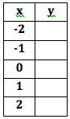
$y={\frac{1}{2}}^{x}$

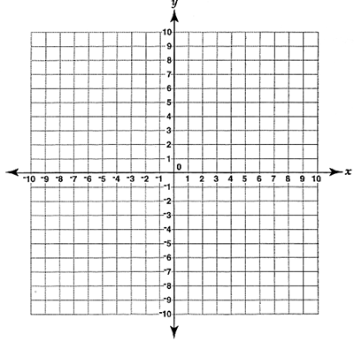

A fish biologist determines that there are approximately 500 trout in Blue Lake. The population is growing at a rate of 3% each year. How many deer will line in the park after 5 years? (2 pts)

Suppose you invest $2,000 in an account that will earn 2.5% compounded quarterly. How much money will be in the account after 5 years? After 12 years?
(3 pts)

A population of amoebas in a petri dish will double in size every 30 minutes. At the start of an experiment the population is 50. The function $f\left(x\right)=50∙2^{x}$, where x is the number of 30 minute periods, models the population growth. How many ameobas are in the petri dish after 3 hours? (3 pts)

Error Analysis: A student evaluated the function $f\left(x\right)=10∙2^{x}$ for $x=-1$ as shown below
$f\left(-1\right)=10∙2^{-1}$
$={20}^{-1}$
$=-20$
Describe and correct the student’s mistake(s). (2 pts)

